Cancellation of May Meeting

Once again, our monthly meeting at Providence Heights has been cancelled. Back on April 22nd, as highlighted in last month’s newsletter, AIUSA presented an excellent online program titled Chinese State Surveillance and “National Security” in Xinjiang. Hope you had a chance to watch that program, which was directly relevant to our group’s new case.

This is the spot in the newsletter where there should be a link taking you to the recording of that online program. We were disappointed to discover, however, that no recording of that program is available. AIUSA’s “Virtual Annual General Meeting” series is continuing. This link will take you to a page where you can find recorded programs and upcoming online programs.
https://www.amnestyusa.org/take-action/events/amnesty-internationals-2020-annual-general-meeting/?utm_source=AGM&utm_medium=Field-MLT&utm_campaign=AGM-Field-MLT

China: Guligeina Tashimaimaiti Released!

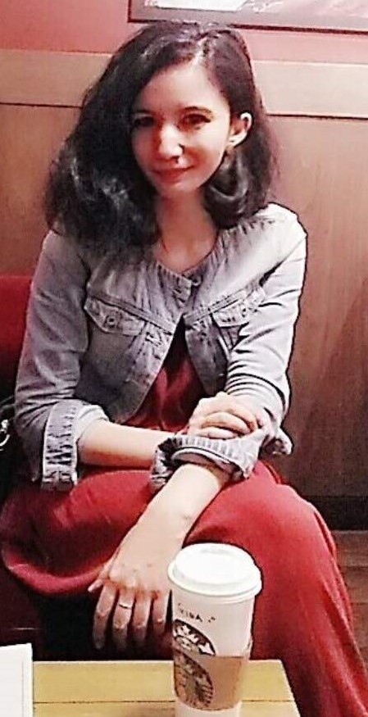 | As outlined in last month’s newsletter, our group recently received a new prisoner case. Guligeina Tashimaimaiti is a member of the Uighur ethnic group from the Xinjiang region of northwestern China. In December 2017, she was about to begin studying for her PhD at Malaysia’s University of Technology, when she decided to make a quick trip home, in order to check on the safety of her parents. As Guligeina’s friends back in Malaysia feared, she disappeared into one of China’s “re-education” concentration camps. We were about to write our first letters on her case when we learned that Guligeina has been released! For more about her release, and for a letter-writing opportunity on another Uighur case, see Page 2.

China: Release of Guligeina Tashimaimaiti

Each month, one of the first steps in putting together the newsletter is to perform an internet search for any recent news concerning our group’s prisoner case. This month, the search for articles about Guligeina Tashimaimaiti produced the startling news that she had been released!

On May 13th the report of her release was published on the website of the Australian section of Amnesty. The information in the report was limited, and that may indicate that there are restrictions on her freedom. When she made her trip back home in December 2017, it was clearly her intention to return to Malaysia to begin work on her PhD. According to the report, however, she has begun teaching English at a school in the Xinjiang region. The report also stated that she had spoken with her family – but in a video call, and not in person.

In any case, we can celebrate the fact that she is alive, that she and her family have been able to communicate, and that she has at least some degree of freedom.

China: Model Letter Calling for Release of Buzainafu Abudourexiti

At the Amnesty Australia website, the report on Guligeina Tashimaimaiti stated that 20,000 Australians had signed an online petition calling for her release. Coupled with the report of that success, the website presented an online petition for a similar Uighur prisoner case, and we have adapted that petition into a model letter for this issue of the newsletter.

The prisoner in question is a young woman named Buzainafu Abudourexiti, who has been imprisoned since 2017. Her case is described on Page 3. What appears below is the text of the Australian petition, which can be sent as a brief letter to the Chinese embassy in Washington. (Due to the pandemic, international mail has been disrupted, so our focus is on targets in DC.) You can also send email to the Chinese embassy (chinaembpress_us@mfa.gov.cn).

Ambassador Cui Tiankai
Embassy of the People’s Republic of China
3505 International Place NW
Washington, DC 20008

Dear Ambassador:

I am extremely concerned for Buzainafu Abudourexiti, who is serving a seven-year sentence at Urumqi Women’s Prison following a secret trial in June 2017. No official documentation about her case, nor the charges she has been convicted of, has been provided to her family.

I am calling for the immediate and unconditional release of Buzainafu Abudourexiti, unless there is sufficient credible and admissible evidence that she committed an internationally recognized offense and is granted a fair re-trial in line with international standards.

Please ensure that Buzainafu Abudourexiti has regular, unrestricted access to family and lawyers of her choice, is not subject to torture and other ill-treatment, and receives regular and unrestricted access to medical care on request or as necessary.

China: Model Letter Calling for Release of Buzainafu Abudourexiti (continued)

Buzainafu Abudourexiti was the subject of an AIUSA Urgent Action back in 2017, at the time she was sentenced to prison. The original Urgent Action notice was updated in July 2019, and it remains on the AIUSA website.

Like Guligeina Tashimaimaiti, Buzainafu was probably targeted by Chinese officials because she had studied abroad. In her case, she studied in Egypt.

The background material below was adapted from a model letter provided in the Urgent Action update.

Buzainafu Abudourexiti continues to be held in incommunicado detention after she was suddenly detained in March 2017 and sentenced in a secret trial to seven years in prison.

There is still no information about the charges against her, but it is believed that it may be part of a wider crackdown on Uyghur students who studied abroad. Buzainafu Abudourexiti returned to China in 2015 after studying in Egypt for two years. She is at grave risk of torture and other ill-treatment.

Buzainafu Abudourexiti remains in incommunicado detention after she was sentenced on 5 June 2017, without any legal representation, to seven years imprisonment. She is currently being held at Urumqi Women’s Prison.

She was taken away from her parents’ house in Urumqi, on 29 March 2017 and transferred to the city of Akesu, 1,000km away. No official documentation about her case, including what charges she was convicted of, has ever been provided.

While Buzainafu Abudourexiti was pregnant at the time of her arrest, her husband later learned from officials in Xinjiang that the child was already dead in her womb when she was detained. Nothing is known about her current health status.

Buzainafu Abudourexiti went to Egypt to study Islam for two years and returned to Urumqi in early 2015 to work at her father’s company while learning English. Planning to join her new husband, Almas Nizamidin, in Australia, she then went back to Egypt in September 2015 to collect the documentation for her visa application.

After returning to Urumqi in December 2015, she then received the necessary clearance from the Urumqi police department and Almas proceeded to lodge an application for her Australian spousal visa. Buzainafu Abudourexiti was detained shortly after that and their application is still pending.

After reading this summary of her case, you can readily understand why Amnesty Australia has a special interest in working for Buzainafu’s release.

Washington: AIUSA Launches Campaign Concerned with COVID-19 Pandemic

In a press release dated May 13th, AIUSA announced a new campaign, as described below. On the next page is a screen snapshot of a graphic describing the goals of the campaign.

This week, Amnesty International USA launched a new campaign, #RightsNow! to demand basic human rights in the COVID-19 response and recovery. From healthcare for all to freeing people in immigration detention, to addressing the terrifying spike in gun sales and fighting for a just recovery, it’s a campaign demanding that President Trump and Congress put human rights at the center of the COVID-19 response.

COVID-19 has exposed the fault lines in our society we already knew existed, but it has also challenged us to see what could be when the pandemic ends. The RightsNow! Campaign is about embracing that challenge, and demanding a society that commits to basic human rights—access to equitable health care, adequate food and shelter, safety and a livelihood.

RightsNow! is not just about surviving this pandemic – it’s about creating a new future where all of us can live in dignity and thrive.

AIUSA has created this website for the new campaign:
https://rightsnow.amnestyusa.org/

Washington: AIUSA Launches Campaign Concerned with COVID-19 Pandemic (continued)

